Web Application Penetration Test Report
Football Hub — Django Web Application
Target: http://18.170.42.8 (EC2 instance: football-hub-test)
Attacking host: pen-test (Kali Linux, AWS EC2)
Assessment type: Authorized black-box web application penetration test
Date: August 2026
Prepared by: Babila Lewis

Independent, self-directed security assessment of a personal Django project, performed with full owner authorization on infrastructure I control.

1. Executive Summary
This report documents an authorized penetration test carried out against the Football Hub Django application, deployed on a dedicated AWS EC2 instance (football-hub-test, public IP 18.170.42.8). The assessment was conducted from a separate, purpose-built Kali Linux EC2 instance (pen-test) and followed a standard penetration testing lifecycle: reconnaissance, scanning and enumeration, vulnerability analysis, exploitation/verification, and remediation.
The overall security posture of the application at the time of testing was good. No Critical or High severity vulnerabilities were identified. One Medium severity finding was identified — an outdated nginx reverse proxy version affected by CVE-2026-1642 (SSL Upstream Injection) — and this was remediated and independently re-verified during the engagement. A small number of Low and informational findings were also identified, primarily relating to missing security headers, the absence of HTTPS, and minor information disclosure via default files (robots.txt, sitemap.xml).
A summary of all findings, their severity, and remediation status is provided in Section 6.

2. Scope
- In-scope target: football-hub-test EC2 instance (18.170.42.8), running the Football Hub Django application behind an nginx reverse proxy, deployed via Docker Compose (nginx, Django/Gunicorn app, PostgreSQL, Redis).
- Testing was performed from a dedicated attacking host (pen-test EC2 instance, Kali Linux) under the same AWS account, with full authorization as the account/application owner.
- Testing was limited to the football-hub-test instance and its exposed services; no other AWS infrastructure was in scope.
- Both unauthenticated external testing and local host-level review (following legitimate SSH/Instance Connect access) were performed.

3. Methodology
The assessment followed a standard penetration testing cycle:
- Phase 1 — Reconnaissance: passive and active information gathering (Nmap, SpiderFoot OSINT).
- Phase 2 — Scanning & Enumeration: directory/endpoint discovery and web server misconfiguration checks (Gobuster, Nikto).
- Phase 3 — Vulnerability Analysis: authenticated tooling scan for known CVEs and misconfigurations (Tenable Nessus Essentials).
- Phase 4 — Exploitation & Verification: confirmation of findings and post-remediation re-testing (Metasploit Framework).
- Phase 5 — Remediation: fixes applied directly to the affected service, followed by independent re-verification.

Tools & Techniques Used
Category | Tools
Reconnaissance | Nmap, SpiderFoot (OSINT)
Enumeration | Gobuster, Nikto
Vulnerability scanning | Tenable Nessus Essentials
Exploitation / verification | Metasploit Framework
Infrastructure | AWS EC2, Docker Compose, nginx, Django/Gunicorn, PostgreSQL, Redis
Remediation & re-testing | Docker image version pinning, Nessus/Metasploit re-scan

4. Phase 1: Reconnaissance
An initial Nmap scan confirmed the host was reachable and identified the exposed attack surface: port 80 (HTTP) open, and port 443 (HTTPS) closed — confirming the application was served exclusively over unencrypted HTTP.
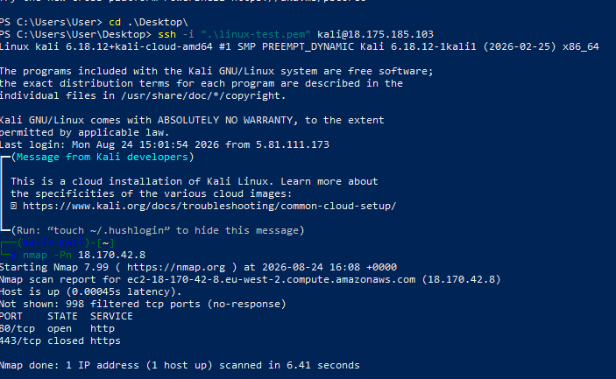
Figure 1 — Initial Nmap scan of 18.170.42.8: port 80 open, port 443 closed.
A follow-up service/version detection scan fingerprinted the web server as nginx 1.27.5. This version was later confirmed via Nessus (Section 5) to be affected by a known Medium-severity CVE. SSH (port 22) was filtered from the tester's vantage point at the time of this scan, consistent with security group rules restricting SSH access.
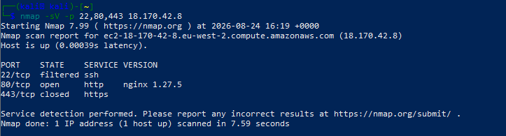
Figure 2 — Nmap service/version scan identifying nginx/1.27.5.
Nmap's default HTTP vulnerability scripts (DOM-based XSS, stored XSS, CSRF) were also run and did not identify any issues at this stage — a useful baseline, though not a substitute for deeper testing.
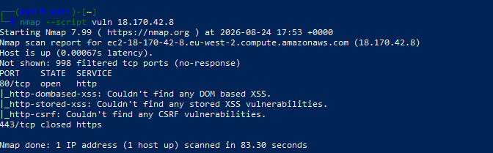
Figure 3 — Nmap vulnerability script scan: no DOM-based XSS, stored XSS, or CSRF issues detected.
SpiderFoot was used to perform automated OSINT reconnaissance against the target IP, covering DNS, netblock, BGP/ASN membership, and open port data. No high, medium, or low severity correlations were flagged by SpiderFoot's built-in rules during this scan.
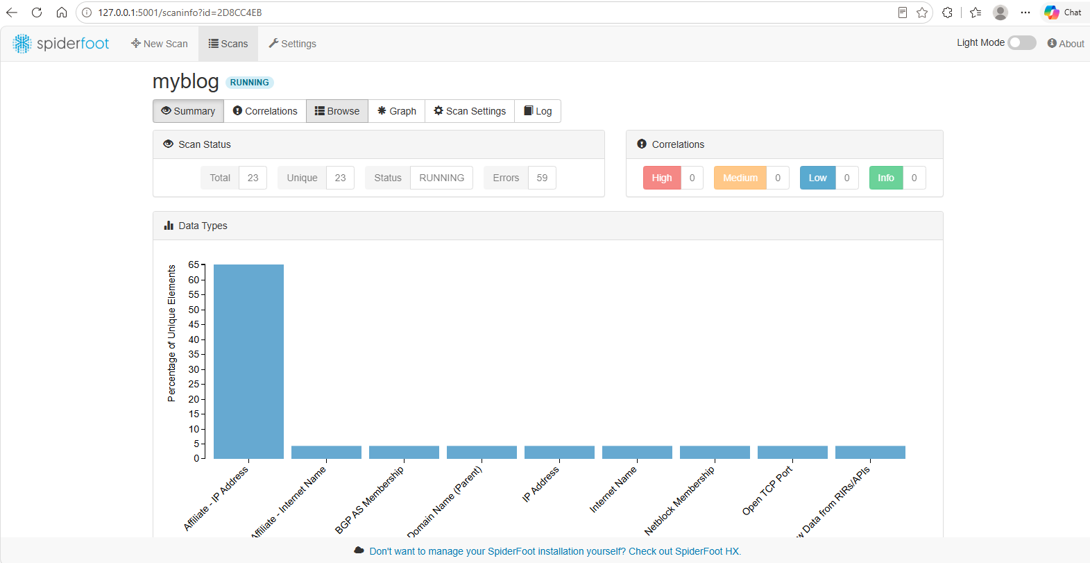
Figure 4 — SpiderFoot OSINT scan summary.

5. Phase 2: Scanning & Enumeration
Gobuster was used to enumerate hidden or undocumented directories and endpoints on the target. This surfaced the application's structure, including administrative and user-facing routes such as /admin/, /dashboard/, /login/, /logout/, /search/, /saved/, /ws/, /privacy-policy/, /careers/, /contact-us/, /feedback/, and a readable /sitemap.xml. No unexpected or clearly sensitive paths (e.g. exposed backup files, .git, or debug endpoints) were discovered.
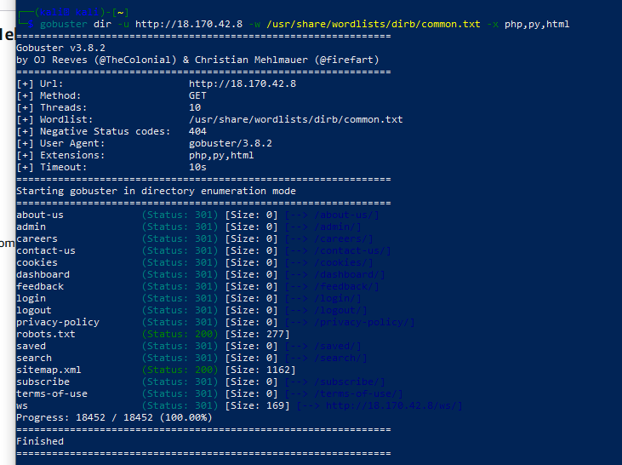
Figure 5 — Gobuster directory enumeration results.
Nikto was run against the web server to check for common misconfigurations. It confirmed the nginx/1.27.5 banner and flagged several missing recommended security headers — Content-Security-Policy, Strict-Transport-Security, Permissions-Policy, and X-Content-Type-Options — along with the presence and readability of robots.txt and sitemap.xml. None of these were classified as high risk on their own, but they represent hardening opportunities.
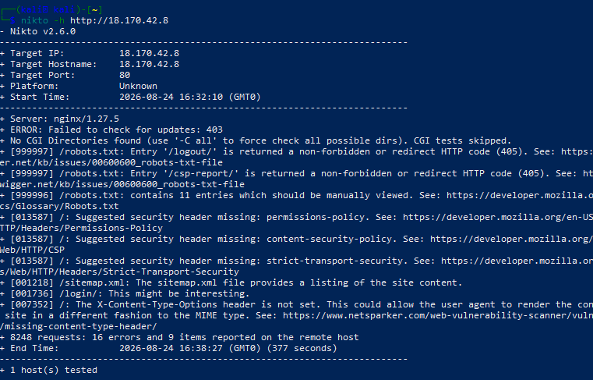
Figure 6 — Nikto web server scan results.

6. Phase 3: Vulnerability Analysis
A full Tenable Nessus Essentials "Basic Network Scan" was run against the target (unauthenticated/unauthenticated-service scan). The scan completed in 10 minutes and identified 15 total findings against the single host: 1 Medium, 1 Low, and 13 Informational. No Critical or High severity findings were identified.
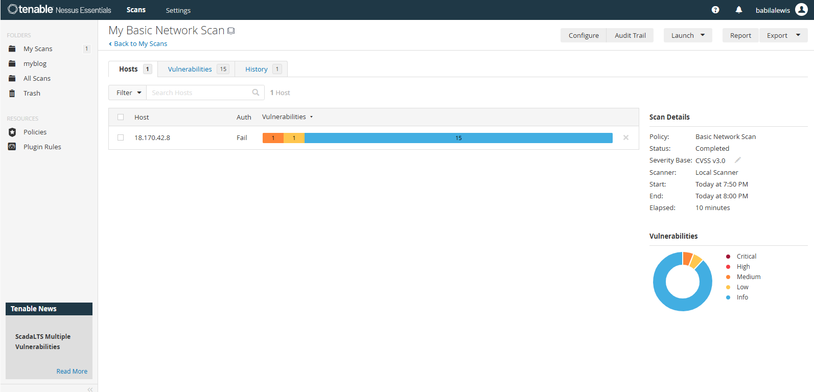
Figure 7 — Nessus Basic Network Scan summary: 0 Critical, 0 High, 1 Medium, 1 Low, 13 Info.
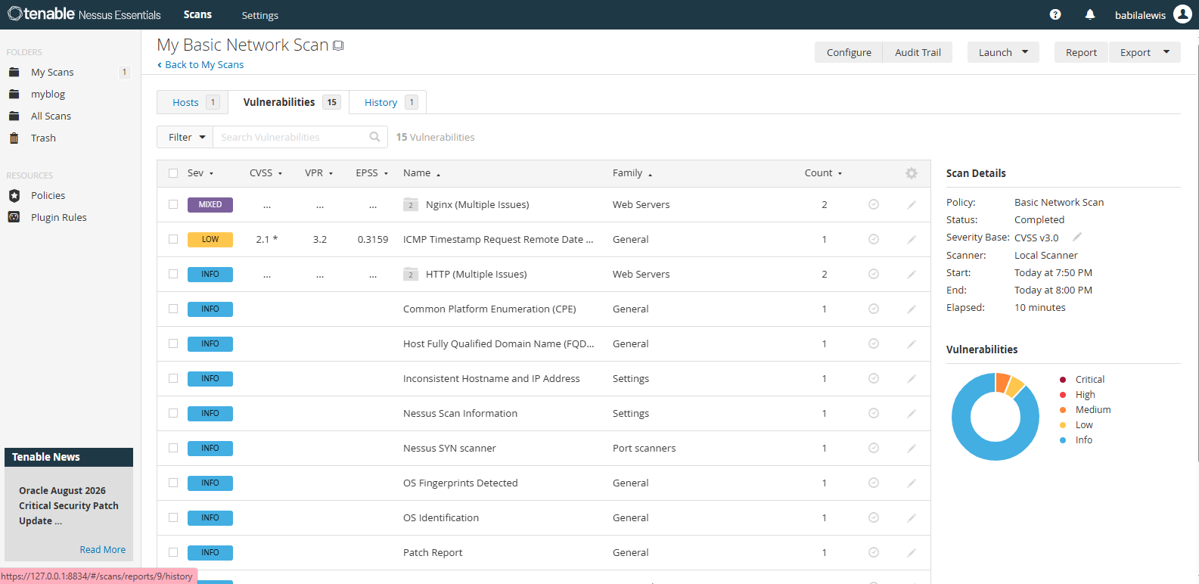
Figure 8 — Full list of the 15 findings, by severity and plugin family.
The single Medium severity finding was an outdated nginx version (1.27.5) affected by CVE-2026-1642 — an SSL Upstream Injection vulnerability affecting nginx versions 1.3.0 up to (but not including) 1.28.2, and 1.29.x prior to 1.29.5. The issue arises when nginx is configured to proxy to upstream TLS servers: an attacker with a man-in-the-middle position on the upstream side could, under certain conditions, inject plaintext data into the proxied response. Exploitation requires an existing MITM position and is not directly exploitable by a remote, unauthenticated attacker without that foothold. Nessus recommended upgrading to nginx 1.28.2 or 1.29.5 or later.
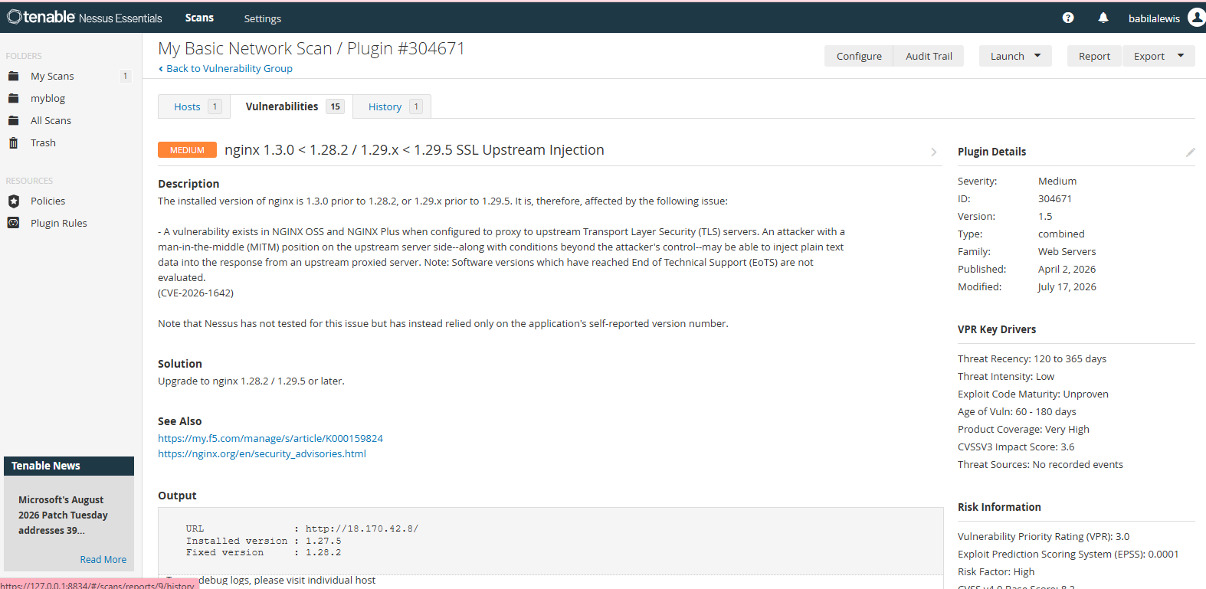
Figure 9 — CVE-2026-1642 (nginx SSL Upstream Injection) detail, as reported by Nessus.
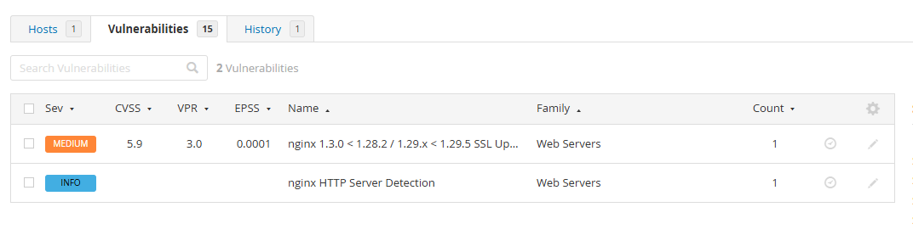
Figure 10 — nginx findings grouped: the Medium CVE and an Informational server-detection entry.
The single Low severity finding was an ICMP Timestamp Request Remote Date Disclosure. The host responds to ICMP timestamp requests, which could allow an unauthenticated remote attacker to determine the system clock, potentially assisting in defeating time-based authentication protocols. This is a minor information-disclosure issue with low real-world exploitability.
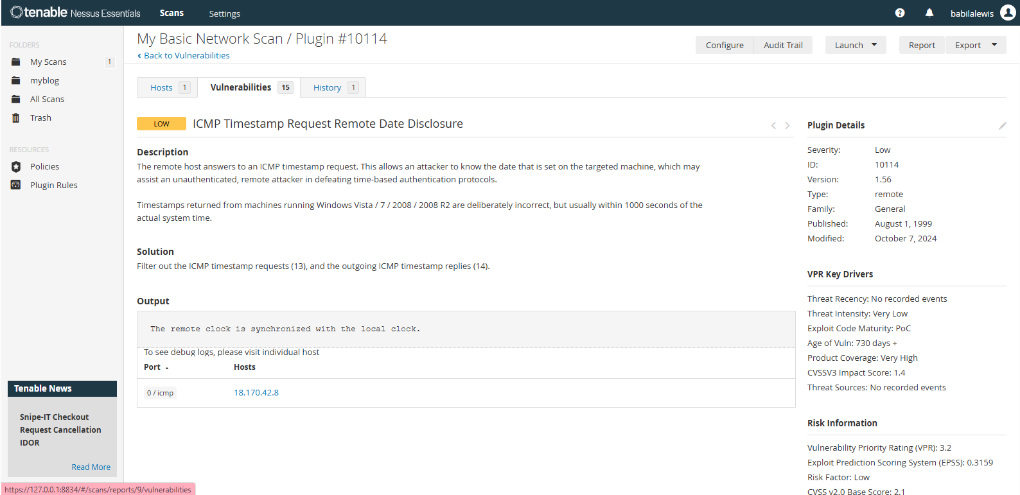
Figure 11 — ICMP Timestamp Request Remote Date Disclosure detail, as reported by Nessus.
The remaining 13 findings were classified as Informational by Nessus and consisted of reconnaissance/fingerprinting data (OS identification, CPE, FQDN, hostname/IP consistency check, scan metadata) rather than exploitable vulnerabilities.

7. Phase 4: Exploitation & Verification
The Metasploit Framework was used to independently confirm findings outside of the Nessus scan, and — critically — to verify remediation after the fix was applied, rather than relying solely on the target's own reported state.
An auxiliary HTTP version scan against the target initially returned nginx/1.27.5, independently corroborating the vulnerable version identified by Nessus and Nmap. Attempts to remediate this on the host were first mis-applied — the nginx upgrade was initially (and mistakenly) run against the Kali attacking host rather than the target itself, which the Metasploit re-scan correctly caught, since it still reported the vulnerable version against the real target.
Root-cause investigation on the target instance found that nginx was not installed via the host's package manager at all, but was running as a Docker container (nginx:1.27-alpine) as part of a Docker Compose stack alongside the Django/Gunicorn application, PostgreSQL, and Redis containers, defined in docker-compose.prod.yml. The fix was applied by updating the pinned image tag to nginx:1.28-alpine and recreating the container:
docker compose -f docker-compose.yml -f docker-compose.prod.yml pull nginx
docker compose -f docker-compose.yml -f docker-compose.prod.yml up -d --force-recreate nginx
Following the fix, the Metasploit HTTP version scan was re-run against the live target (18.170.42.8) and confirmed the running version had changed to nginx/1.28.3 — above the patched threshold for CVE-2026-1642. This provided independent, external confirmation of remediation, rather than relying only on the container logs.
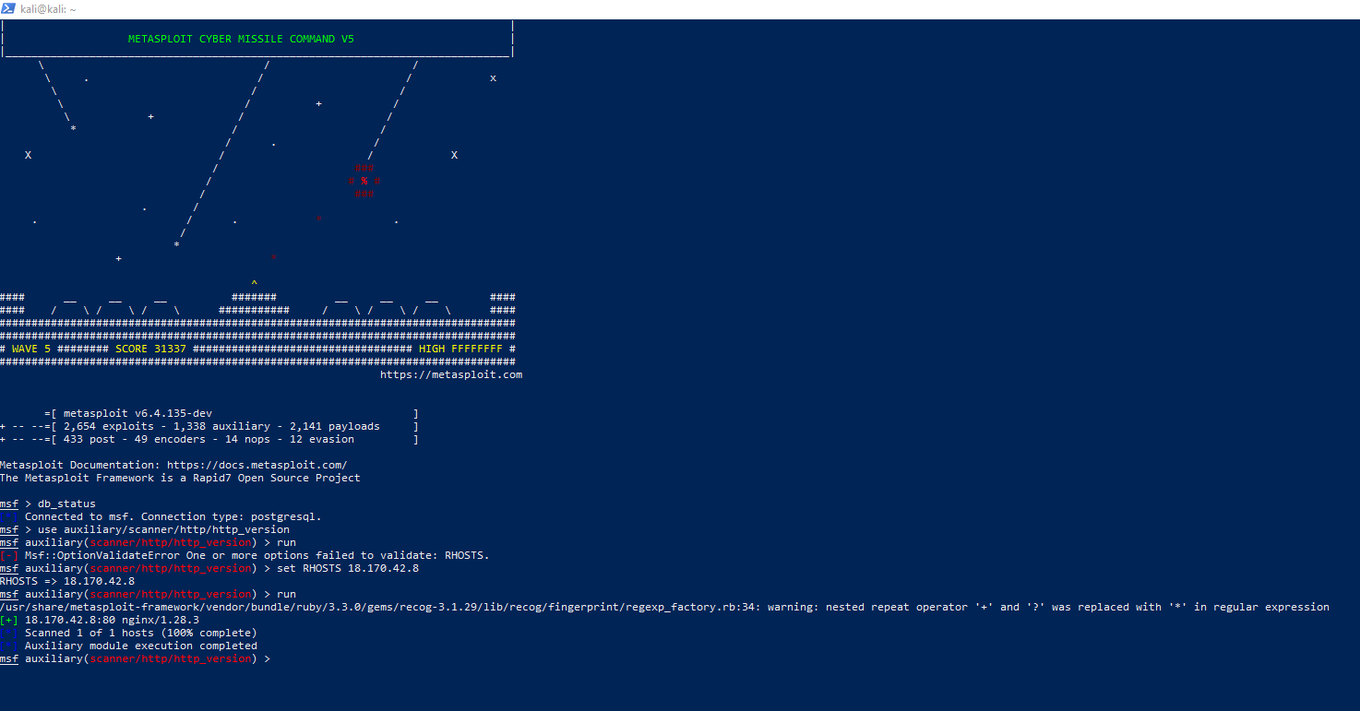
Figure 12 — Metasploit auxiliary/scanner/http/http_version module confirming the patched nginx/1.28.3 after remediation.

8. Summary of Findings
Finding | Severity | Status
Outdated nginx — SSL Upstream Injection (CVE-2026-1642) | Medium | Fixed
ICMP Timestamp Request Remote Date Disclosure | Low | Accepted (not fixed)
Missing security headers (CSP, HSTS, Permissions-Policy, X-Content-Type-Options) | Info | Open
Site served over plain HTTP (no TLS/HTTPS) | Info* | Open
robots.txt / sitemap.xml disclose site structure | Info | Open
Host OS (Ubuntu 24.04) — 64 pending package updates, 61 security | Info | Open

* The absence of HTTPS is not scored as a CVE-based finding by the scanning tools used, but is flagged here as a significant practical exposure — all traffic, including any future login/session cookies, currently travels unencrypted.

9. Remediation Actions & Recommendations

9.1 Remediated during this engagement
- nginx upgraded from 1.27.5 to 1.28.3 (Docker image nginx:1.27-alpine → nginx:1.28-alpine), resolving CVE-2026-1642. Verified externally via Metasploit post-fix.

9.2 Outstanding recommendations
- Enable HTTPS/TLS for the application (e.g. via a certificate on the nginx reverse proxy) — currently the site is served over plain HTTP only, which exposes all traffic, including any future authenticated sessions, to interception.
- Add the missing security headers identified by Nikto: Content-Security-Policy, Strict-Transport-Security (once HTTPS is enabled), Permissions-Policy, and X-Content-Type-Options.
- Apply the 64 pending host-level Ubuntu package updates (61 of which are security updates) on the football-hub-test instance.
- Consider disabling ICMP timestamp responses to close the Low-severity information disclosure finding.
- Restrict or review contents of robots.txt/sitemap.xml if any listed paths are not intended to be publicly enumerable.
- Ensure a working SSH key pair is retained and securely stored for the football-hub-test instance going forward; access during this engagement briefly required AWS EC2 Instance Connect after the original key pair could not be located.

10. Conclusion
The Football Hub Django application demonstrated a solid baseline security posture at the time of testing, with no Critical or High severity vulnerabilities identified across reconnaissance, enumeration, and vulnerability scanning. The single Medium severity finding (CVE-2026-1642, outdated nginx) was successfully remediated and independently re-verified within the engagement, demonstrating an effective and complete vulnerability management cycle from detection through to confirmed resolution. Addressing the outstanding recommendations in Section 9.2 — particularly enabling HTTPS and applying host-level security updates — would further strengthen the application's security posture.

